**Waypoint**

**Objective**: We’re going to make the camera fly through our level.

1. Go to **Assets** on the menu at the top and select **Import** **Package -> Utility**

If you don’t have it then go to [Standard Assets](https://assetstore.unity.com/packages/essentials/asset-packs/standard-assets-for-unity-2017-3-32351) and install.

1. In your newly imported Assets go to **Standard Assets -> Utility** and find **WaypointCircuit.cs** and **WaypointProgressTracker.cs**

Using Asset Packs

* Don't worry about understanding everything
* do the best with what you have
* use other peoples work where you can
* have faith you’ll dig into the details when needed
* continue to build your fundamental knowledge

1. Select your terrain and then click the Y axis on your gizmo so you have a top down view of your terrain.

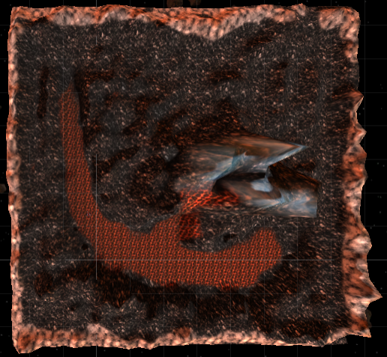

1. Create new **Empty Game Object**, reset its position, and call it **Circuit**.
2. Create an **Empty *Child* Game Object** we’re not going to name it. What you’re going to do is create multiple child game objects and place them in sequential order forming a track on your terrain. You want to have 5- 10 child gameObjects.
3. Click on the X axis and make sure that they are slightly above the **terrain** and not too low.

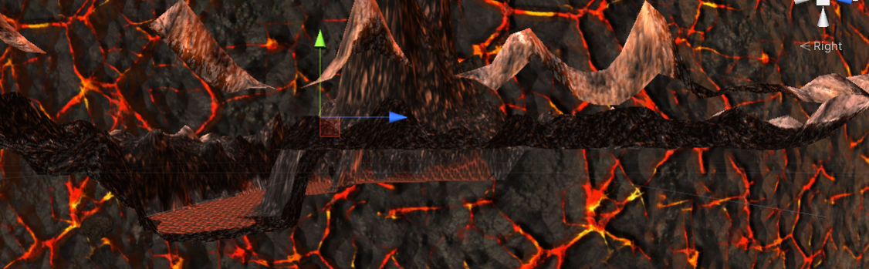

1. Go back to a top down view and click on the **Circuit** in your hierarchy. **Add** **Component** and look for the **Waypoint** **Circuit** Script.
2. Click **Assign using all child objects**  then it will go and find all the child objects and assign it to a list. And look, it's visualizing a circuit on the screen for you.

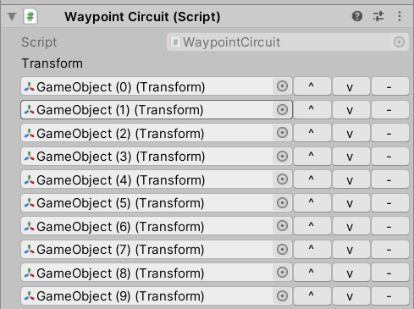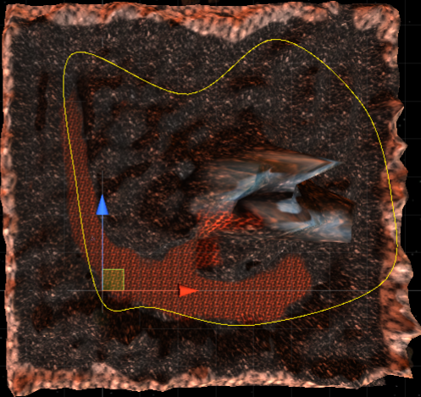

1. Now go in and adjust the location of your waypoints until you get a circuit you like. Now it smooths out the journey between these two different way points using a particular mathematical model that we don't need to get into right now.
2. Click the **Auto Rename numerically from this order** button. If anything goes wrong its easier to remove the entire script and read the game objects.
3. Now lets get the camera to follow the circuit. Click on the **Main** **Camera** and click **Add** **Component**. Select the **Waypoint** **Progress** **Tracker** script. Now in this new component look for the **Circuit** field. Lets go ahead and drag and drop our **Circuit from the hierarchy** on to this circuit field.
4. In this same Waypoint Progress Tracker component look for the **Target** field and drag and drop the **Main** **Camera** from the hierarchy to this field.

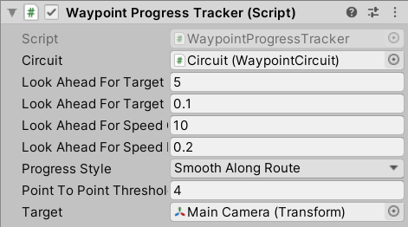

1. Click play to see everything we’ve done so far!

**Troubleshoot**: If you’re getting an error go to line 255 in Wayppointcircuit.cs file specifically the for loop

for (int i = -1; i < items.arraySize; ++i)

and change it to

for (int i = 0; i < items.arraySize;  i++)